

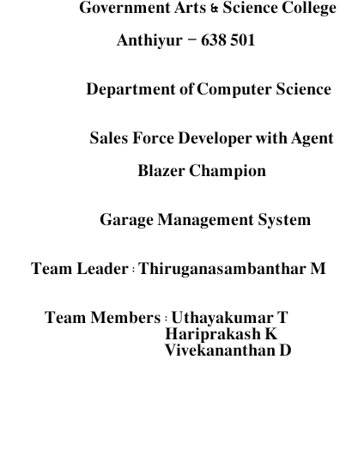

PROJECT OF SALESFORCE DEVELOPER

GARAGE MANAGEMENT SYSTEM

To optimize customer details, appointment, service records, and billing & feedback for automotive garages.

By

# PROJECT OVERVIEW

The Garage Management System (GMS) project on Salesforce is a CRM solution aimed at transforming the way automotive garages manage customer relationships, vehicle service records, and day-to- day operations. With centralized customer profiles, service histories, and appointment scheduling, the system empowers garages to deliver more personalized and efficient customer service. Automated reminders and service notifications help enhance customer engagement, ensuring regular maintenance and timely service updates to boost customer satisfaction.

In addition to customer management, the GMS CRM includes comprehensive vehicle tracking and work order management, allowing technicians and advisors to access detailed service histories, track service progress, and assign tasks seamlessly. An integrated parts inventory module ensures that essential components are in stock, with automated reordering for low-stock items to prevent service delays. Technicians can use mobile access to view work orders and inventory on the go, optimizing workflow and reducing downtime.

Finally, the GMS CRM supports billing and invoicing, providing a streamlined system for generating service estimates, digital invoices, and online payment options. With built-in analytics and reporting, managers gain insights into customer trends, revenue, and operational efficiency, enabling data-driven decisions for business growth. The system is designed to scale with the garage, offering robust data security and compliance, making it a future-proof solution for modern garage management needs.

# OBJECTIVES

* **Enhance Customer Retention and Loyalty:** By providing personalized service reminders, streamlined appointment scheduling, and post-service follow-ups, the GMS CRM aims to build long-term customer relationships and increase repeat visits.
* **Optimize Resource Allocation s Technician Efficiency:** Efficient scheduling, real-time work order tracking, and inventory management help maximize technician productivity, reduce wait times, and ensure that resources are allocated effectively for each service job.
* **Increase Revenue through Data-Driven Upselling:** With insights into customer preferences and service history, the CRM enables garages to offer tailored service recommendations and upsell additional maintenance packages, driving revenue growth.
* **Reduce Operational Costs through Automation:** By automating routine tasks like appointment reminders, parts reordering, and invoicing, the GMS CRM minimizes manual workload, reduces errors, and cuts down operational costs.
* **Improve Business Insights and Strategic Planning:** Advanced reporting and analytics provide managers with valuable insights into service trends, technician performance, and financial metrics, supporting informed decision-making and strategic business growth.

# KEY FEATURES

#### Customer details:

* + - Store and manage customer details including contact information, service history, and preferences.
    - Access comprehensive service records for customer insights and tailored service.

#### Appointment:

* + - Automated reminders and notifications to reduce no- shows.
    - Integrated calendar to optimize working time.

#### Service records:

* + - Track detailed service information including service type, parts used, and associated costs.
    - Link service records to specific customer appointments for easy tracking and reference.

#### Billing details:

* + - Generate and manage billing details, linking them to service records.
    - Track payment status and send timely payment reminders.
    - Automated invoice generation and email notifications for a streamlined payment process.

#### Feedback:

* + - Collect and manage customer feedback post-service.
    - Track ratings and comments to enhance service quality.
    - Analyze feedback trends for continuous improvement.

# DETAILED PROCESS

## Activity – 1

### Salesforce account Creation s Activation

* Create a Developer Account by providing all the required details and Activate the account.
* Go to https://developer.salesforce.com/signup.

## Activity – 2

### Object Creation

* Create all the required objects with the given label name and format.

#### Customer details Object

* Enter the label name >> Customer Details
* Plural label name >> Customer Details
* Enter Record Name Label and Format
* Record Name >> Customer Name
* Data Type >> Text

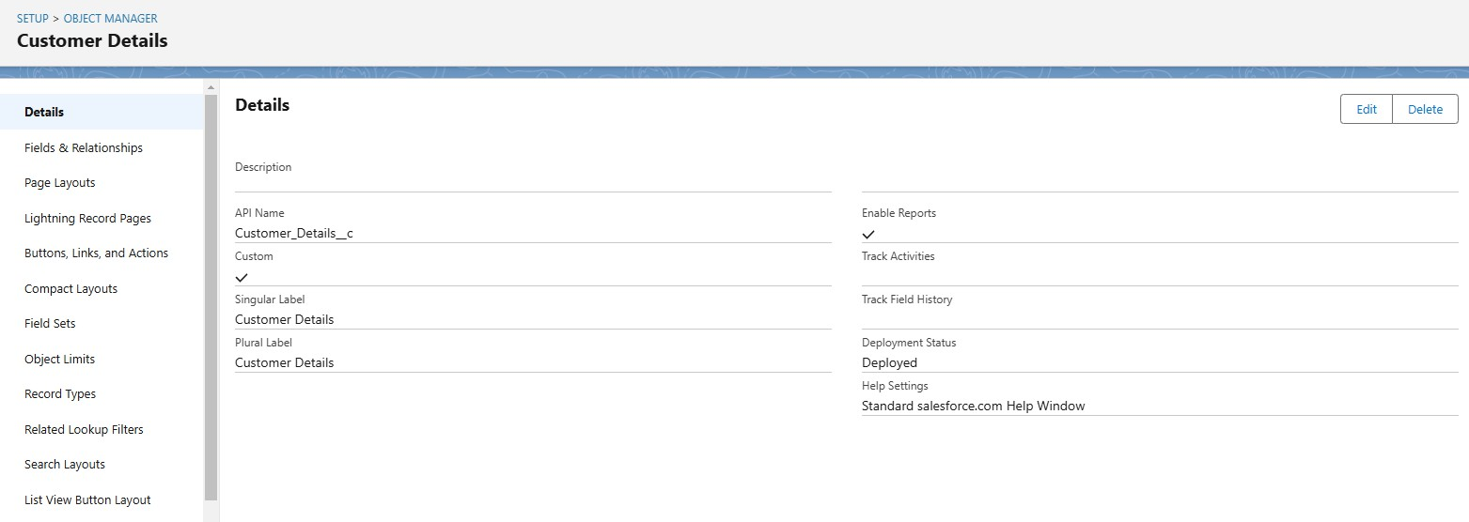

#### Appointment Object

* Enter the label name >> Appointment
* Plural label name >> Appointments
* Enter Record Name Label and Format
* Record Name >> Appointment Name
* Data Type >> Auto Number
* Display Format >> app-{000}
* Starting number >> 1

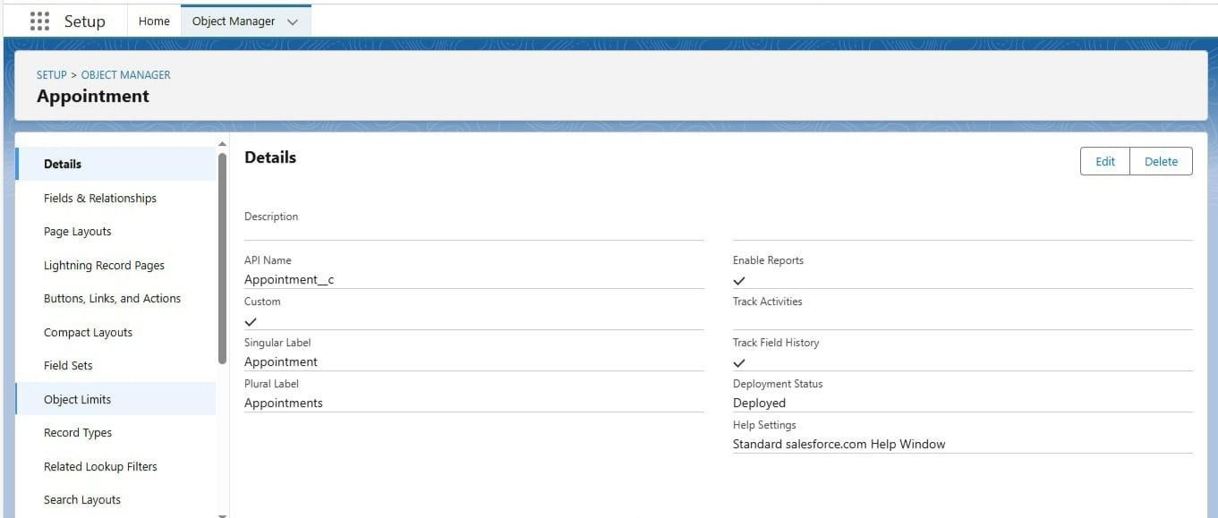

#### Service records Object

* Enter the label name >> Service records
* Plural label name >> Service records
* Enter Record Name Label and Format
* Record Name >>Service records Name
* Data Type >> Auto Number
* Display Format >> ser-{000}
* Starting number >> 1

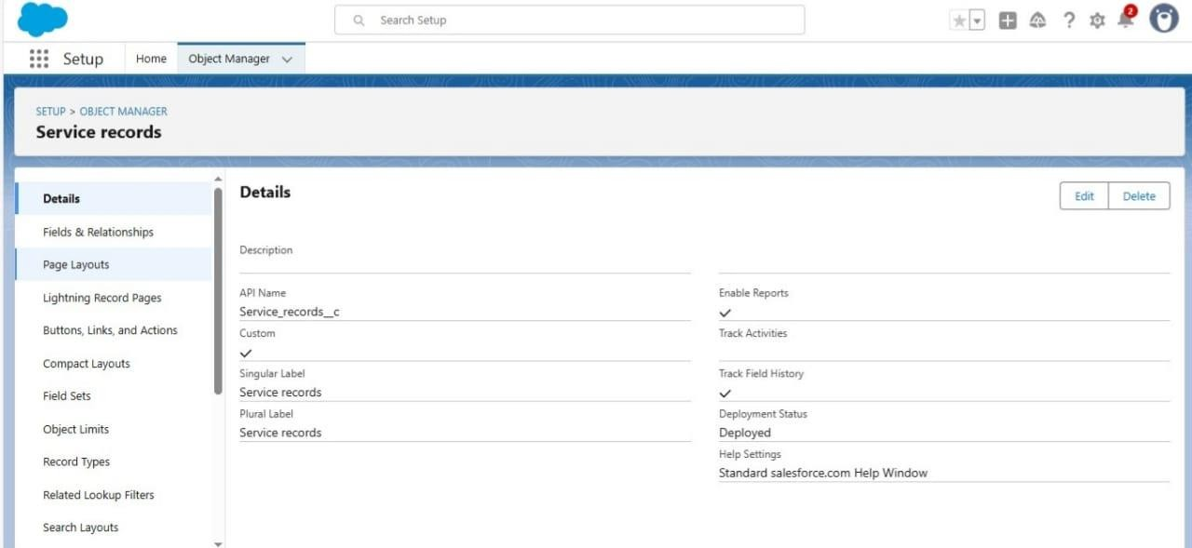

#### Billing details s Feedback Object

* Enter the label name >> Billing details and feedback
* Plural label name >> Billing details and feedback
* Enter Record Name Label and Format
* Record Name >> Billing details and feedback Name
* Data Type >> Auto Number
* Display Format >> bill-{000}
* Starting number >> 1

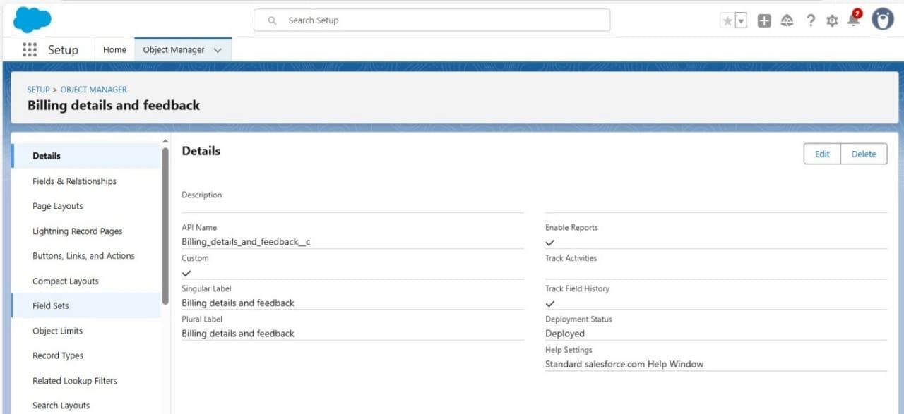

## Activity – 3

### Custom Tabs Creation

* A tab is like a user interface that is used to build records for objects and to view the records in the objects.
* Create these Custom tabs for every Object by following below steps:
* Select Object(Customer Details) >> Select the tab style >> Next (Add to profiles page) keep it as default >> Next (Add to Custom App) uncheck the include tab .
* 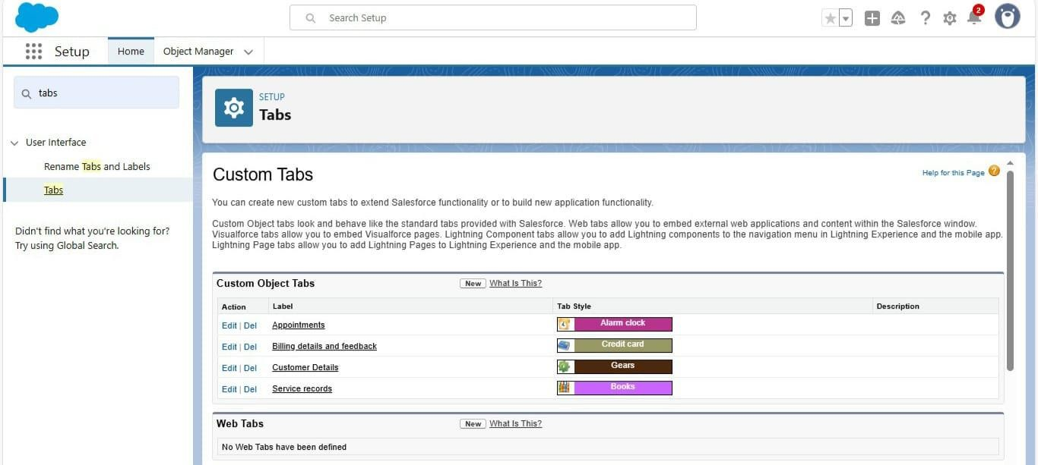 Make sure that the Append tab to users' existing personal customizations is checked.

## Activity – 4

### Create a Lighting App

1. Fill the app name in app details as Garage Management Application >> Next

>> (App option page) keep it as default >> Next >> (Utility Items) keep it as default >> Next.

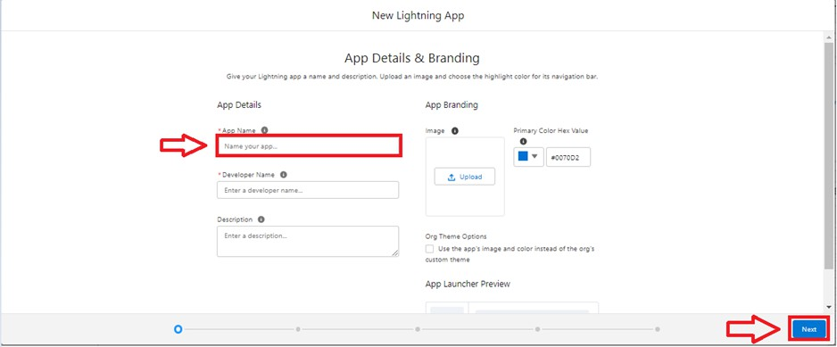

1. To Add Navigation Items:

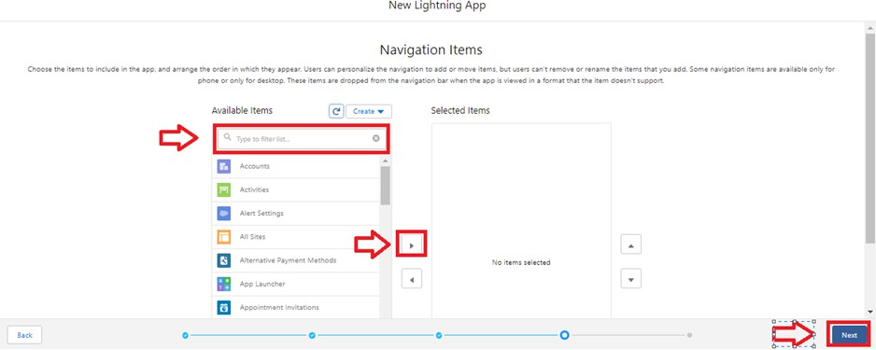

1. Select the items (Customer Details,Appointments, Service records, Billing details and feedback, Reports and Dashboards) from the search bar and move it using the arrow button >> Next.

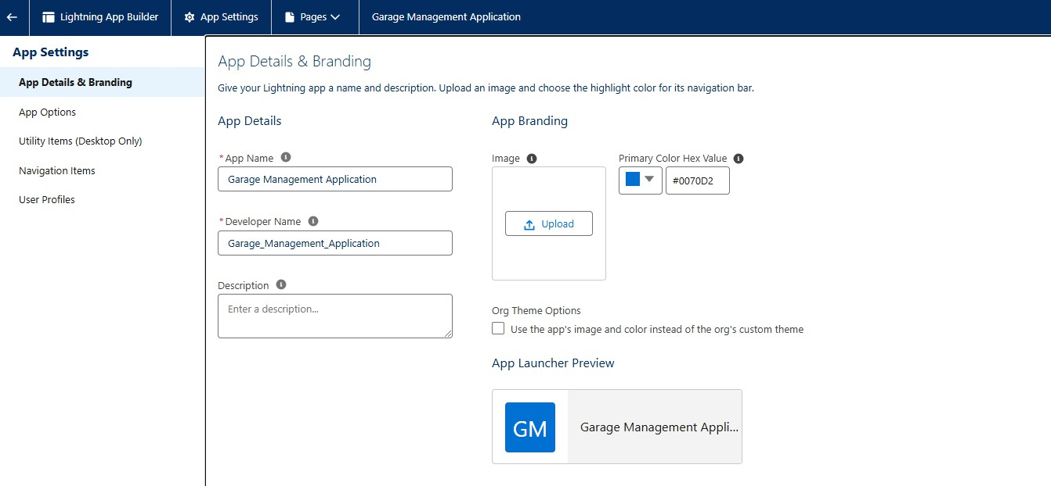

## Activity – 5

### Field Creation for every object:

Create fields for each and every object as per shown in below images.

* **Customer details object**

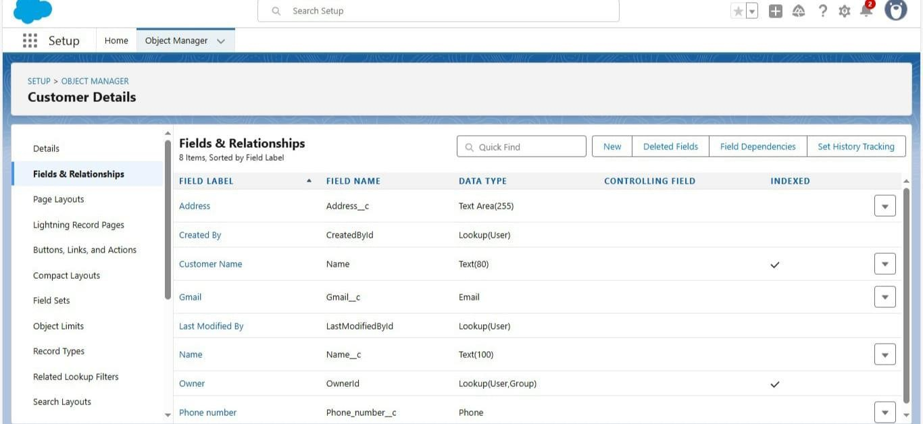

* **Appointment object**

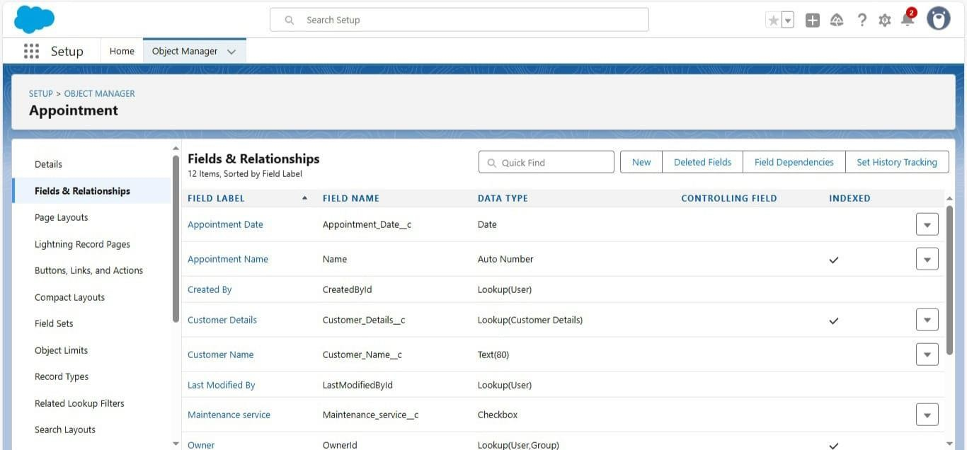

* **Service records object**

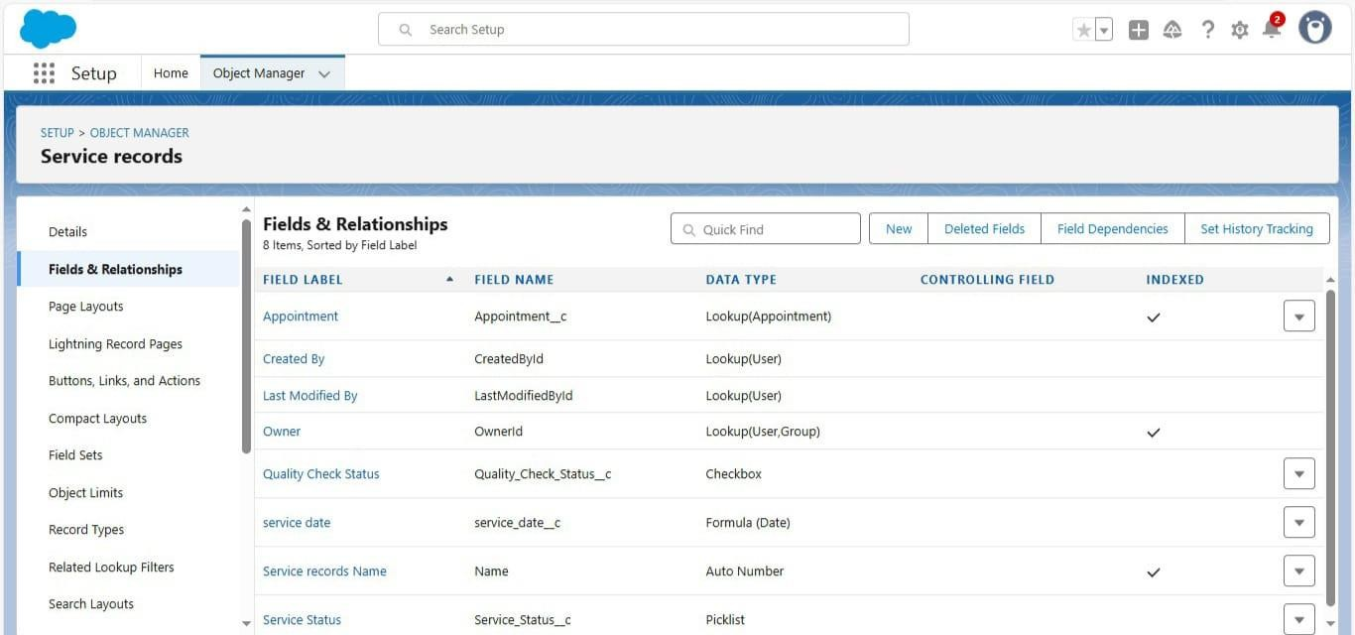

* **Billing details s Feedback object**

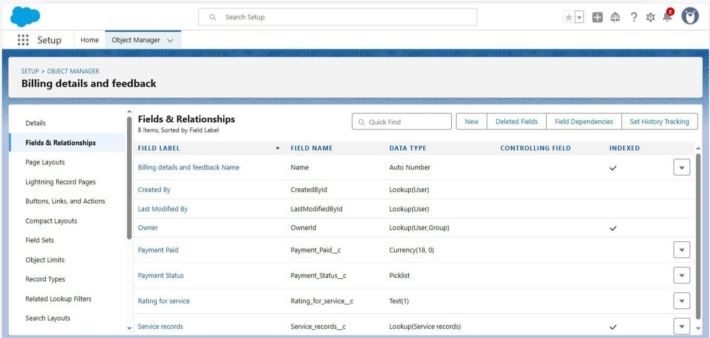

## Activity – 6

### Validation Rules

* **For Appointment**
* Enter the Rule name as “ Vehicle ”.
* Insert the Error Condition Formula as : -

- NOT(REGEX( Vehicle_number_plate c , "[A-Z]{2}[0-9]{2}[A-Z]{2}[0-9]{4}"))

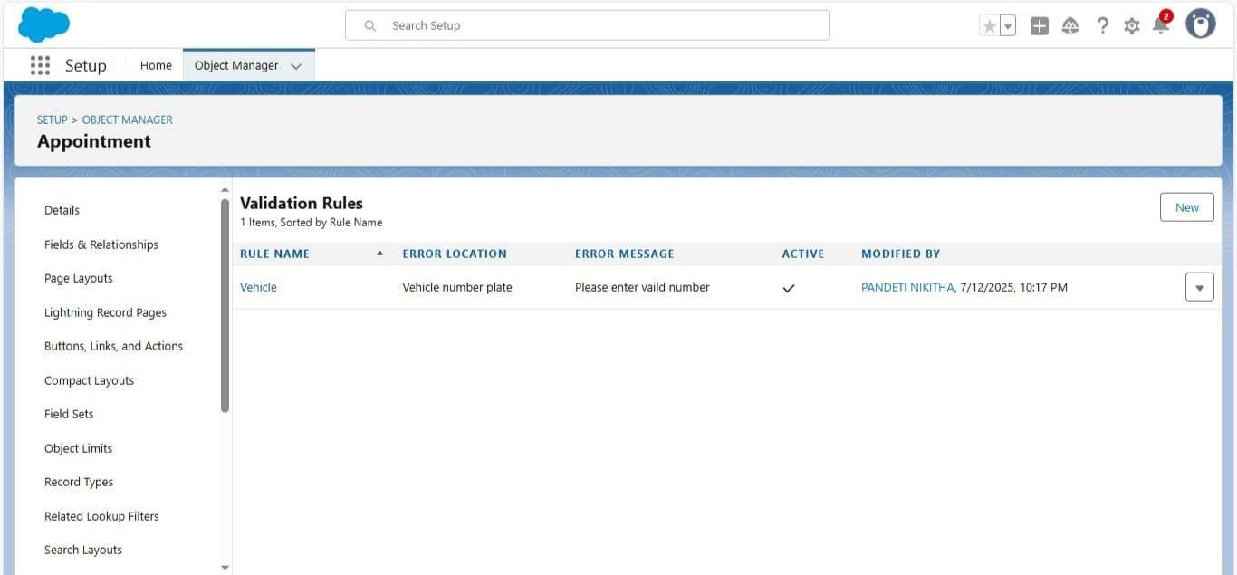

### - For Billing details s Feedback

* Enter the Rule name as “ rating_should_be_less_than_5”.
* Insert the Error Condition Formula as : -
* NOT( REGEX( Rating_for_service c , "[1-5]{1}"))
* Enter the Error Message as “rating should be from 1 to 5”, select the Error location as Field and select the field as “Rating for Service”.

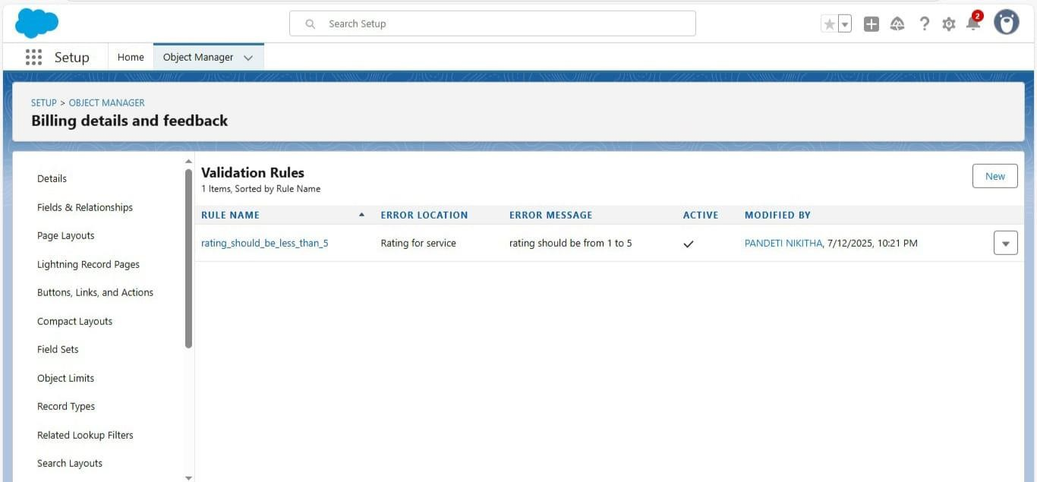

## Activity – 7

### Duplication Rules

#### Matching Rule:

* Give the Rule name : Matching customer details
* Unique name : is auto populated
* Define the matching criteria as:

|  |  |
| --- | --- |
| Field | Matching Method |
| 1. Gmail | Exact |
| 2. Phone Number | Exact |

**-** Create a matching rule for the Customer details Object with the given criteria.

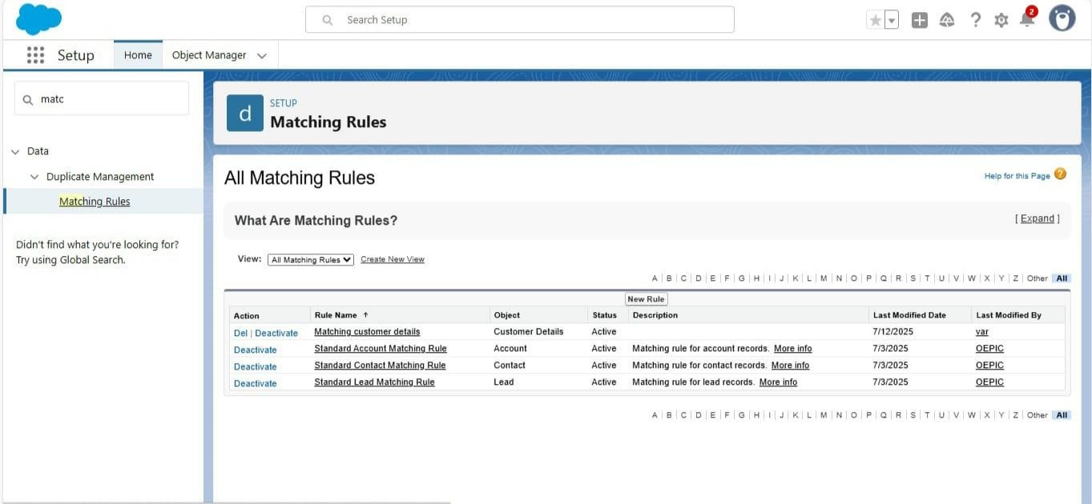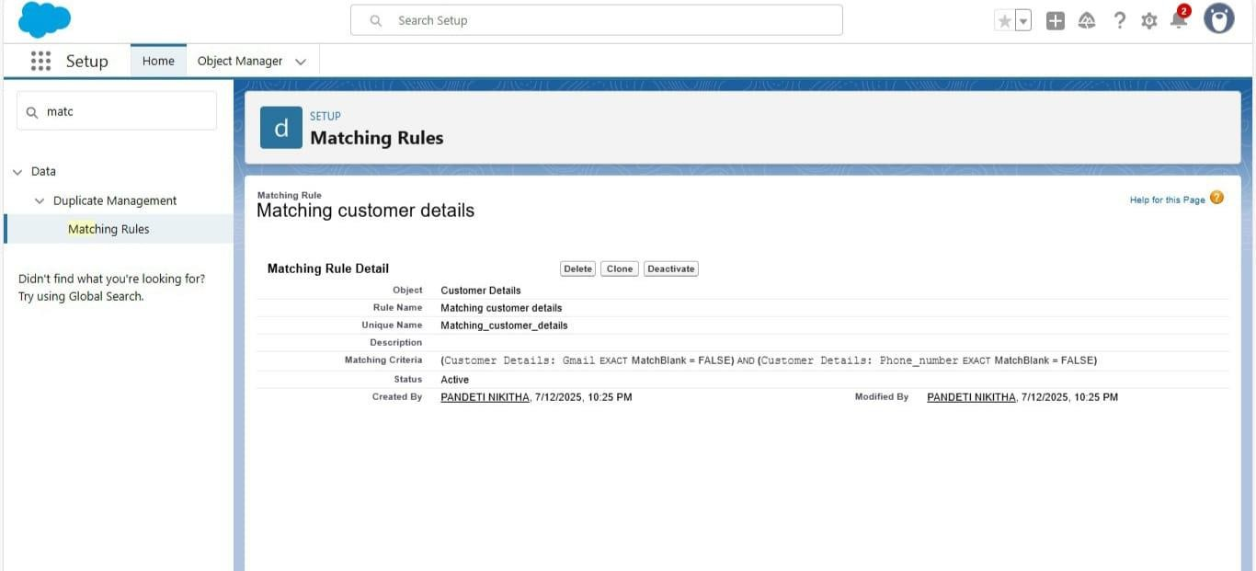

#### -Duplicate Rules:

Create a duplicate rule for the same customer details object which allows the duplication in input fields.

Steps:

* Give the Rule name as : Customer Detail duplicate.
* Select the matching rule : Matching customer details.

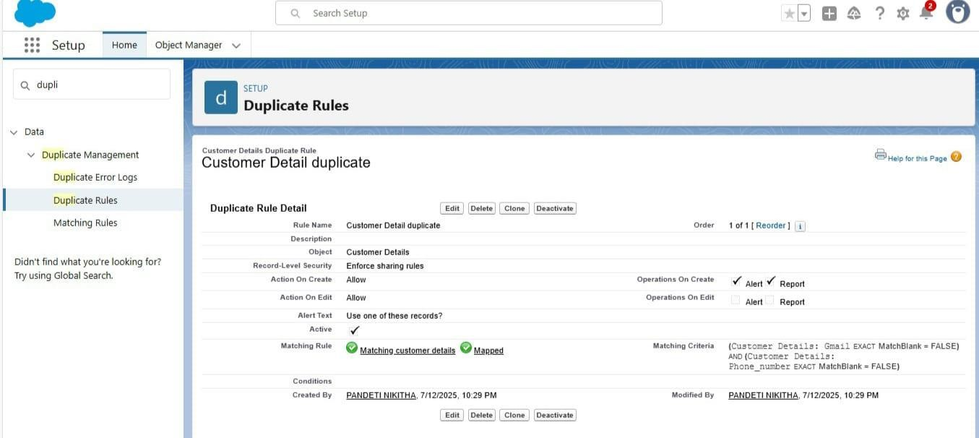

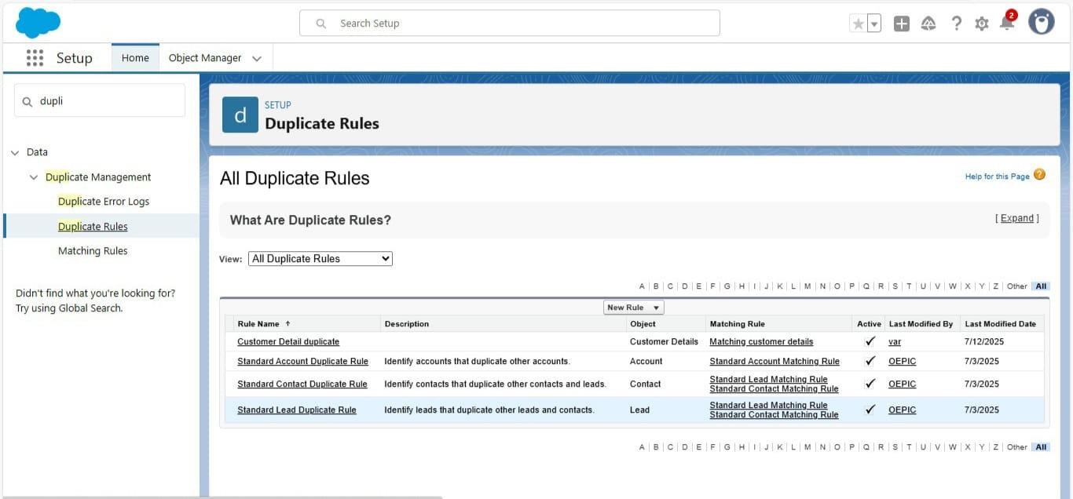

## Activity – 8

### Creating Profiles

#### Manager Profile

* 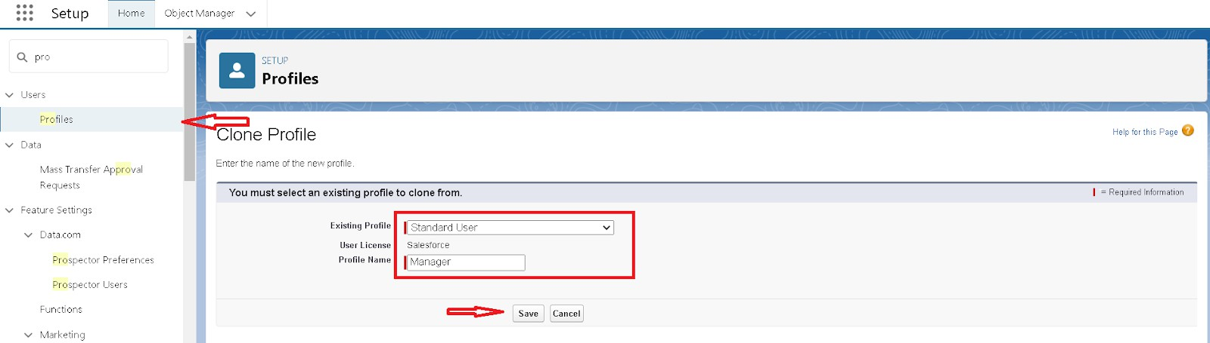

Select the Custom App settings as default for the Garage management.



* Scroll down to Custom Object Permissions and Give access permissions for Appointments,Billing details and feedback , service records and customer details objects as mentioned in the below diagram.

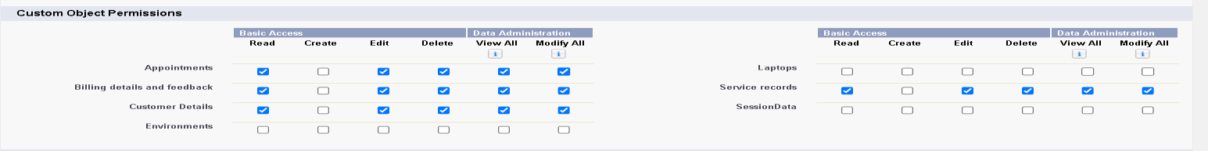

-

- Changing the session times out after should be “ 8 hours of inactivity”.

* Change the password policies as mentioned :
* User passwords expire in should be “ never expires ”.
* Minimum password length should be “ 8 ”.
* 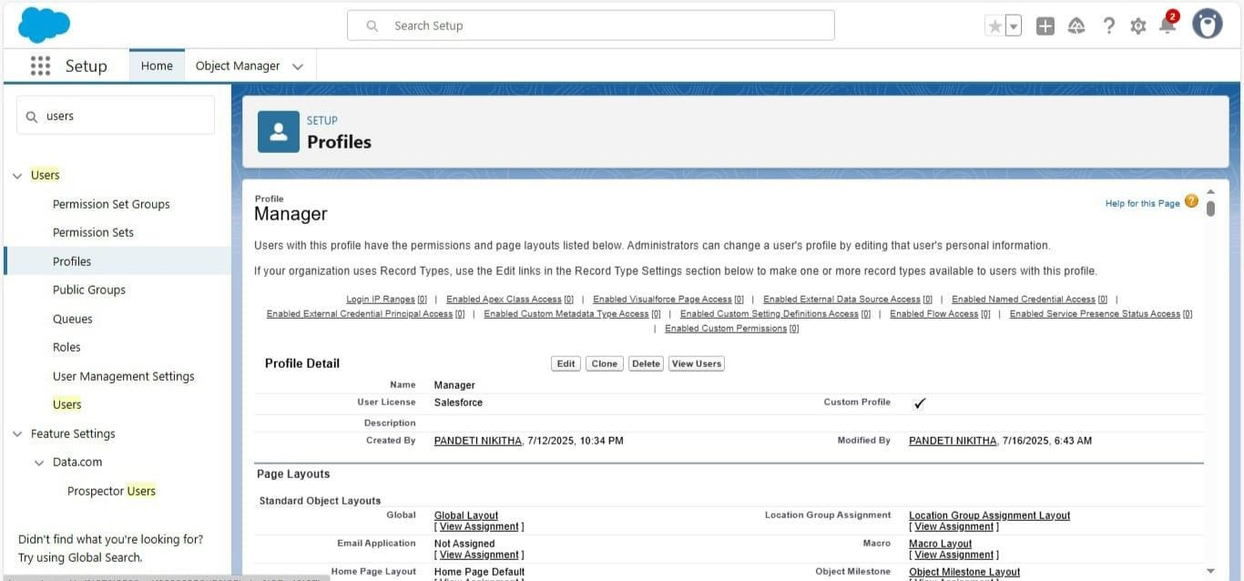

#### Sales Person Profile

* Select the Custom App settings as default for the GArage management.
* Scroll down to Custom Object Permissions and Give access permissions for Appointments,Billing details and feedback , service records and customer details objects as mentioned in the below diagram.
* 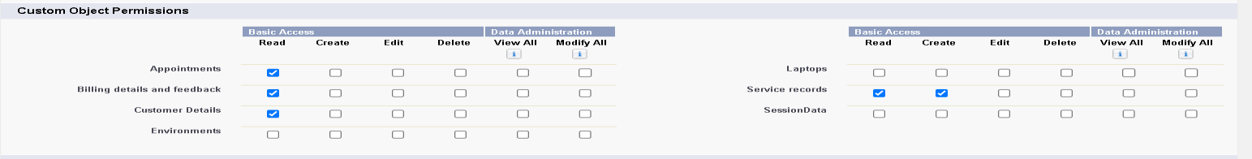

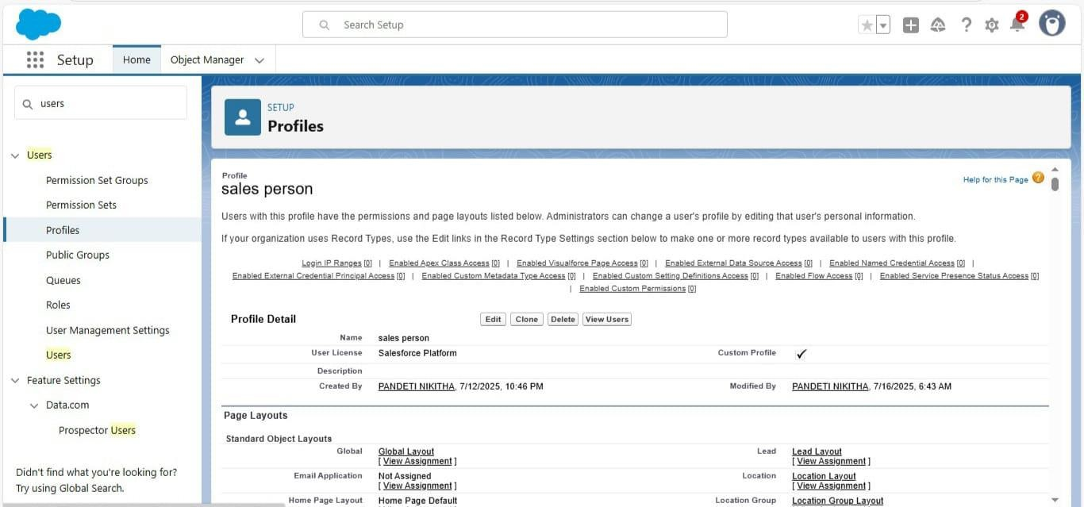

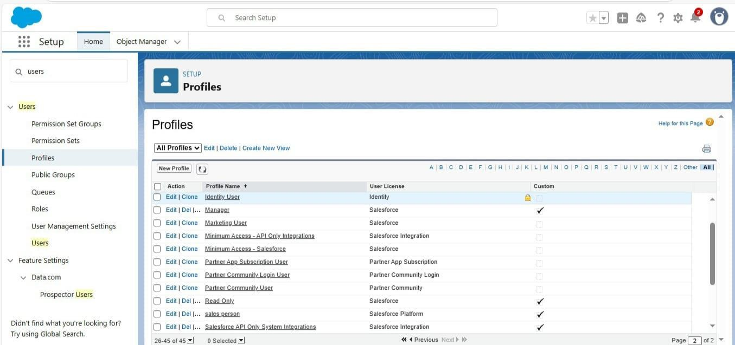

## Activity – G

### Roles s Role Hierarchy Manager Role:

-Click on Expand All and click on add role under whom this role works.

-Give Label as “Manager” and Role name gets auto populated.

### Another Role:

-Click plus on CEO role, and click add role under manager.

-Give Label as “sales person” and Role name gets auto populated.

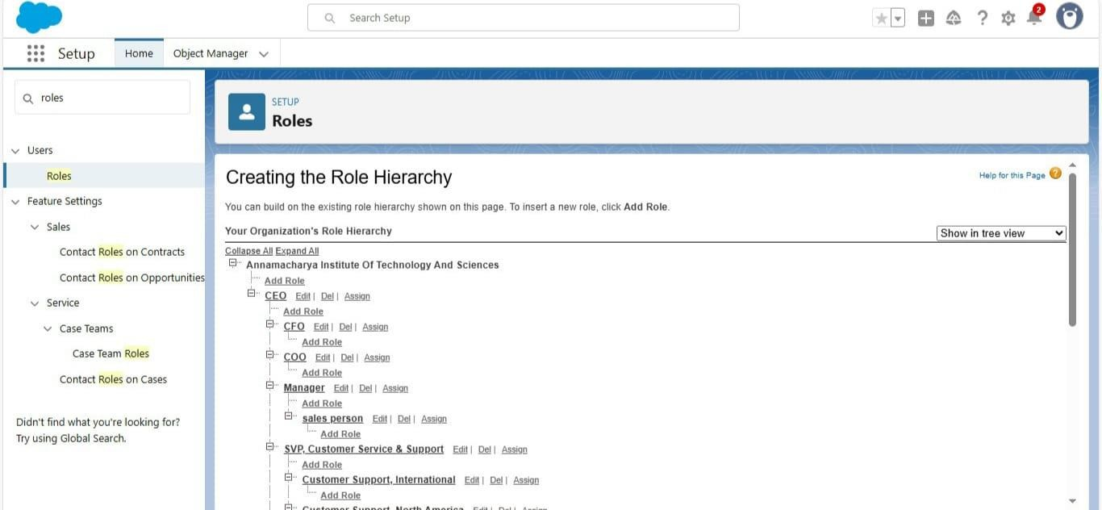

## Activity – 10

### Users

anyone who logs in to Salesforce. Users are employees at your company, such as sales reps, managers, and IT specialists, who need access to the company's records.

### Create Users:

Fill in the fields :

1. First Name : Niklaus
2. Last Name : Mikaelson
3. Alias : Give a Alias Name
4. Email id : Give your Personal Email id
5. Username : Username should be in this form: [text@text.text](mailto:text@text.text)
6. Nick Name : Give a Nickname
7. Role : Manager
8. User licence : Salesforce
9. Profiles : Manager

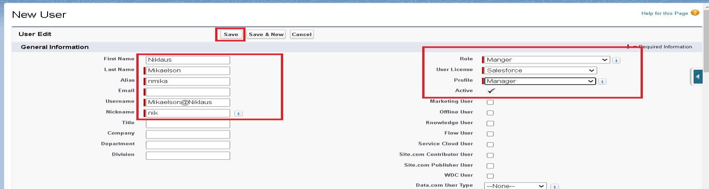

**Create Another Users:**

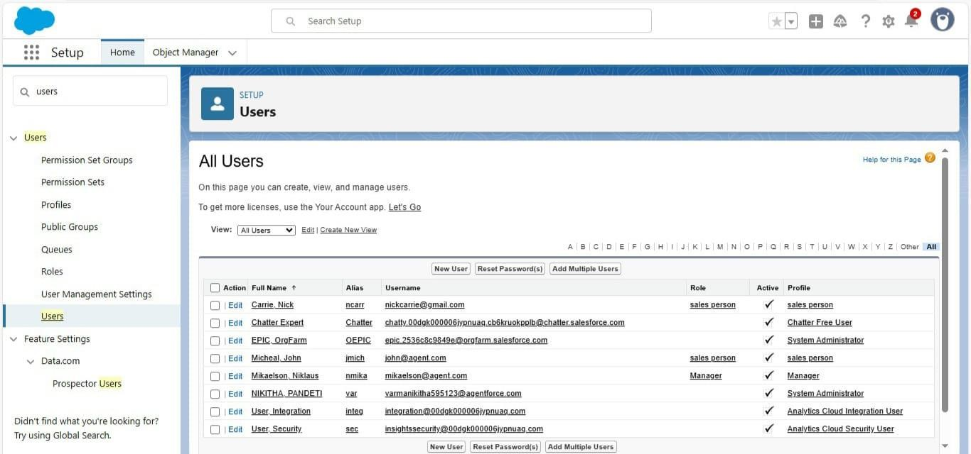

## Activity – 11

### Public Groups

#### - Creating New Public Groups

a valuable tool for Salesforce administrators and developers to streamline user management, data access, and security settings.

Steps:

1. Give the Label as “sales team”.
2. Group name is autopopulated.
3. Search for Roles.
4. In Available Members select Sales person and click on add it will be moved to selected member.

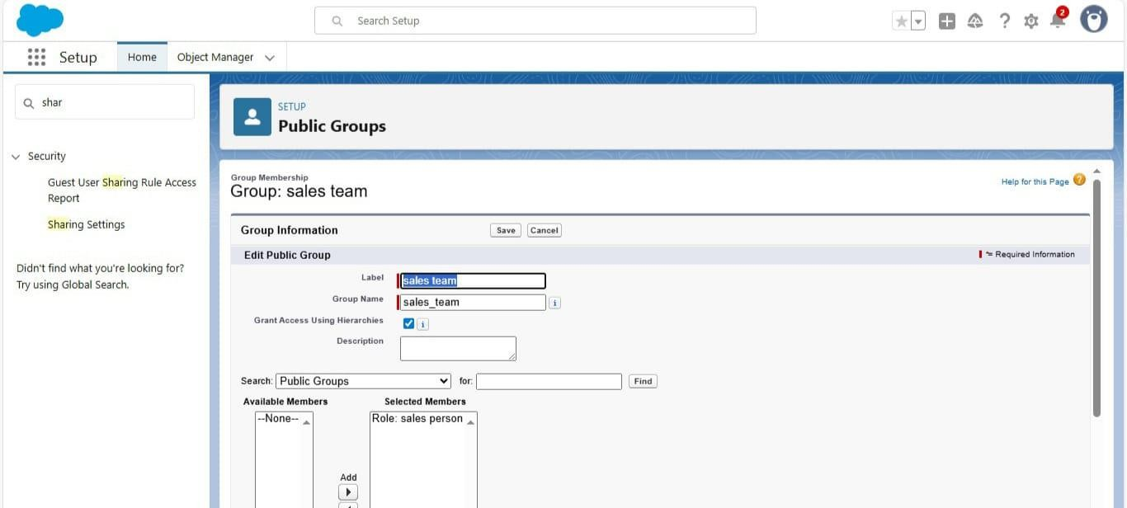

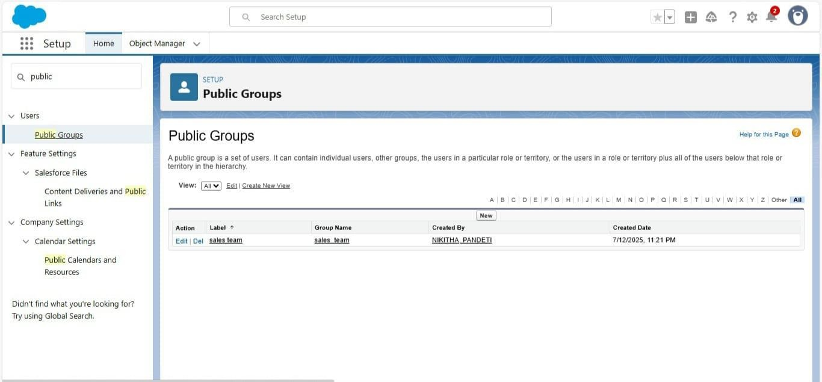

## Activity – 12

**Sharing Settings:** control how records are accessed and shared within your organization. These settings are crucial for maintaining data security and privacy.

Steps:

-Change the OWD setting of the Service records Object to private as shown in fig.

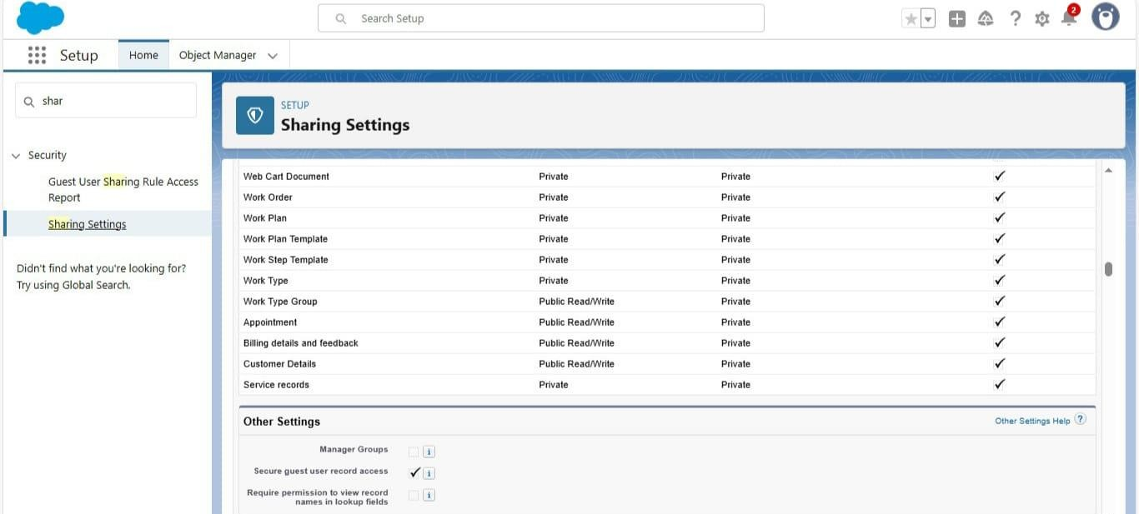

- Scroll down a bit, Click new on Service records sharing Rules

1. Give the Label name as “ Sharing setting”
2. Rule name is auto populated.
3. In step 3 : Select which records to be shared, members of “ Roles ” >> “ Sales person”
4. In step 4: share with, select “ Roles ” >> “ Manager ”
5. In step 5 : Change the access level to “ Read / write ”.
6. Click on save.

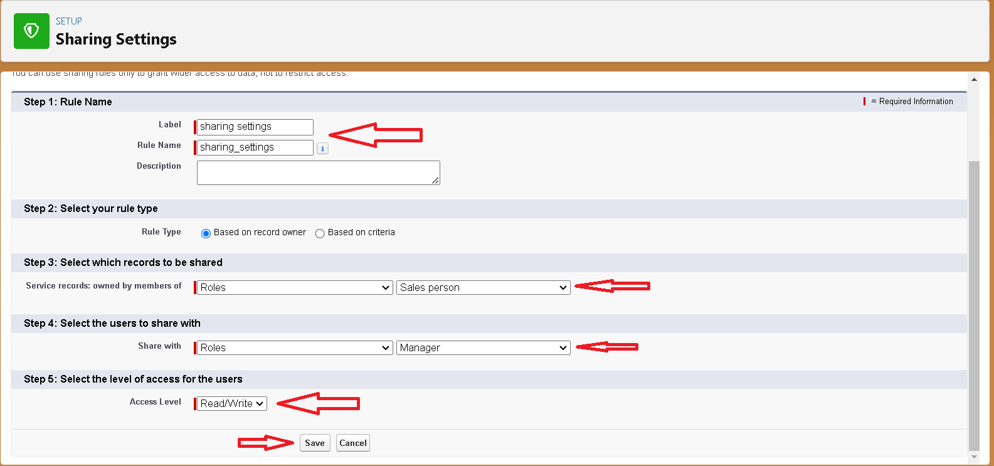

## Activity – 13

**Flows:** a powerful tool that allows you to automate business processes, collect and update data, and guide users through a series of screens or steps.

* + **Record-Trigger Flow**Select the Record-triggered flow and Click on Create.

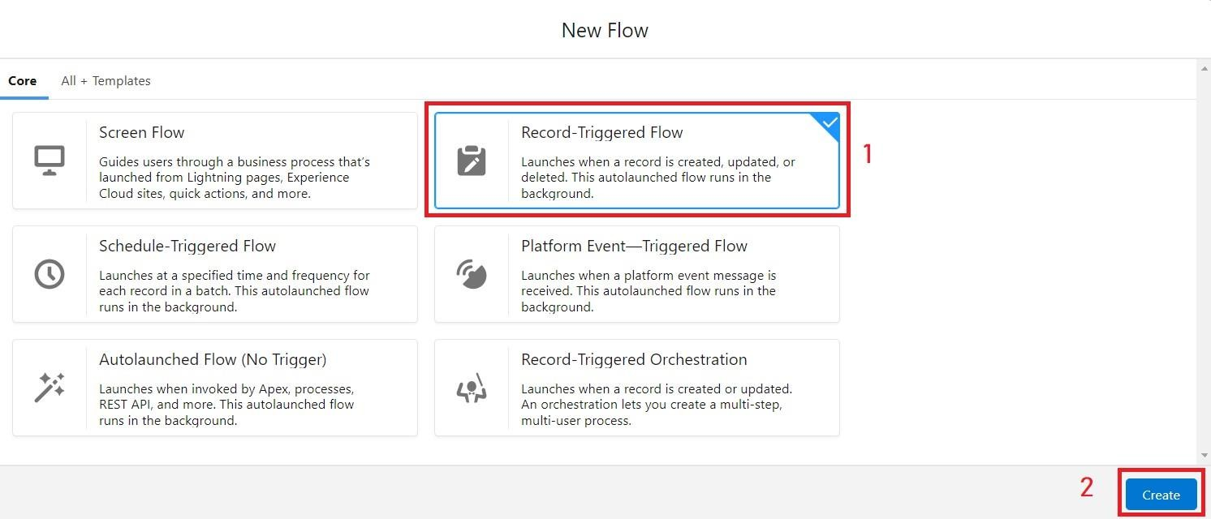

-

* + Select the Object as “Billing details and feedback”in the Drop down list.
  + Select the Trigger Flow when: “A record is Created or Updated”.
  + Select the Optimize the flow for: “Actions and Related Records” and Click on

Done.

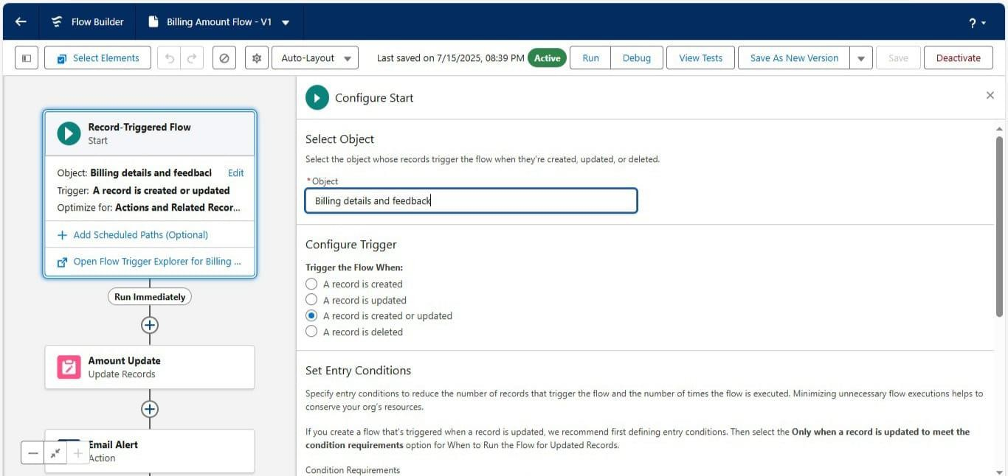

#### Amount Update Flow

* + - * Field : Payment_Paid c
      * Value :

{!$Record.Service_records r.Appointment r.Service_Amount c}

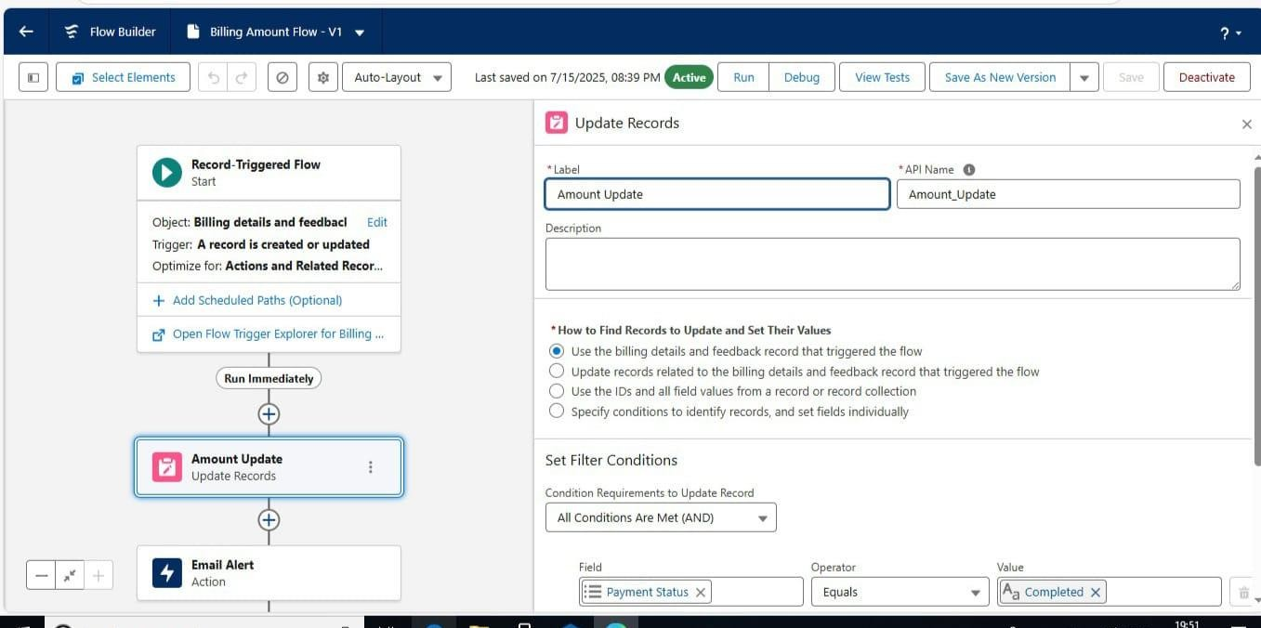

#### Email Alert Flow

* + - * RecipientAddressList:

{!$Record.Service_records r.Appointment r.Customer_Name r.Gmail

c}

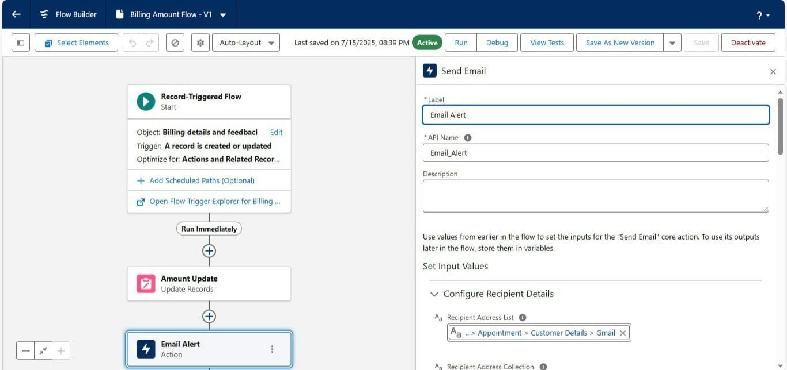

#### Create Another Flow:

1. Select the Record-triggered flow and Click on Create.

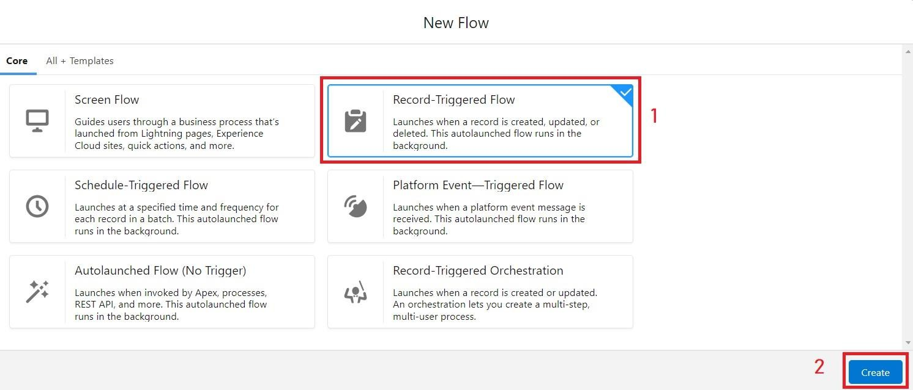

1. Select the Object as “ Service records”in the Drop down list.
2. Select the Trigger Flow when: “A record is Created or Updated”.
3. Select the Optimise the flow for: “Actions and Related Records”

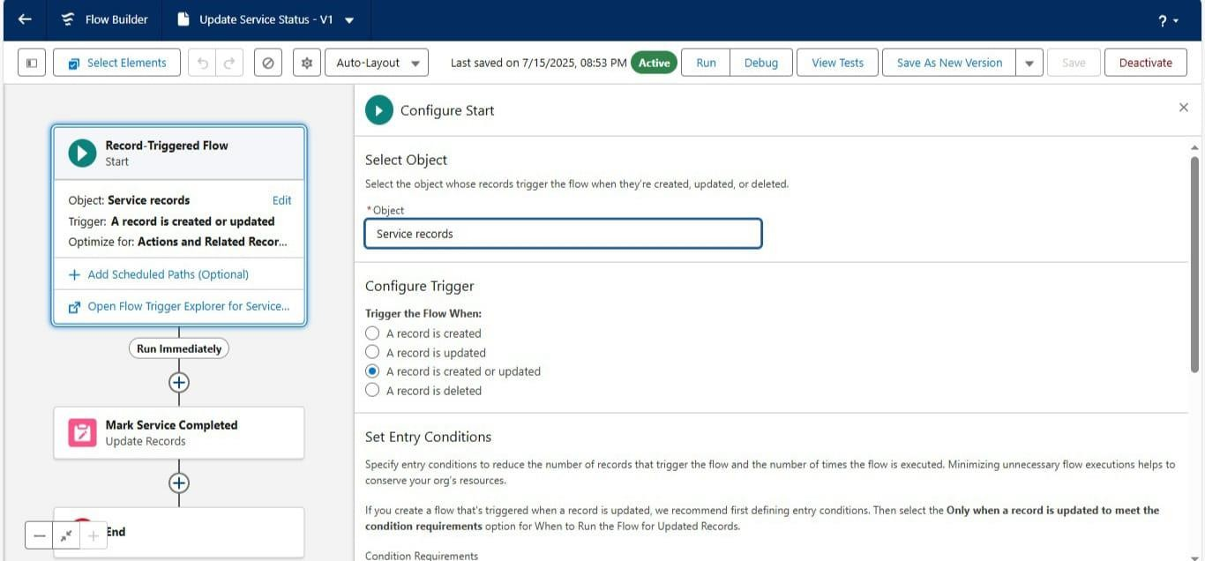

Set a filter condition : All Conditions are met(AND)

1. Field : Quality_Check_Status c
2. Operator : Equals
3. Value : True
4. And Set Field Values for the Billing details and feedback Record
5. Field : Service_Status c
6. Value : Completed

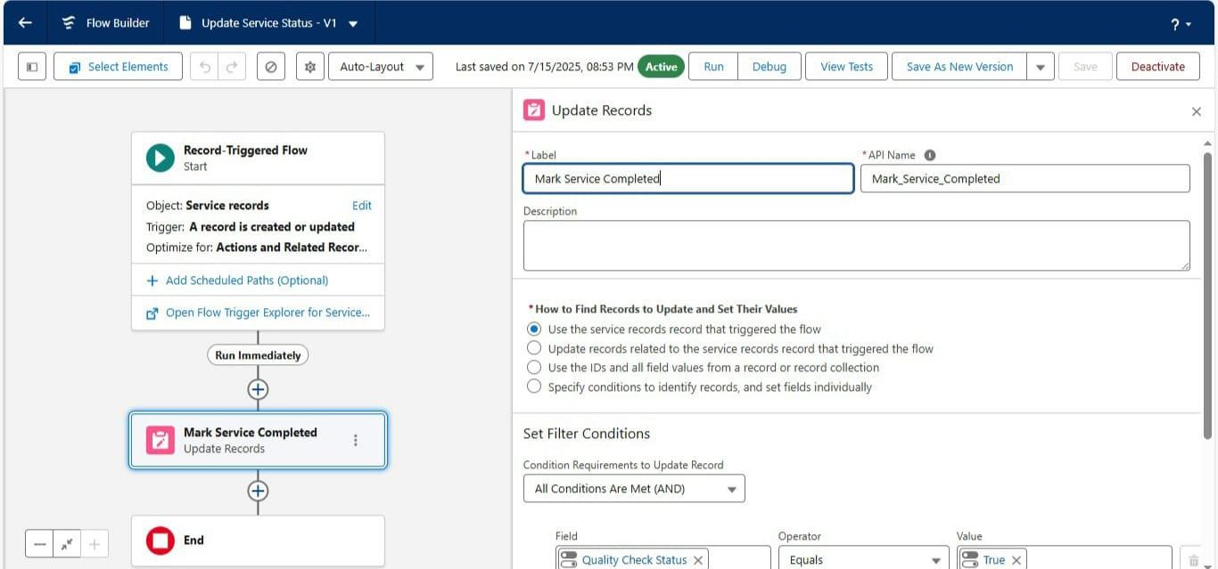

## Activity – 14

### Triggers

1. Name the class as “AmountDistributionHandler ”.

Code:

public class AmountDistributionHandler {

public static void amountDist(list<Appointment c> listApp){ list<Service_records c> serList = new list <Service_records c>();

for(Appointment c app : listApp){

if(app.Maintenance_service c == true && app.Repairs c == true && app.Replacement_Parts c == true){

app.Service_Amount c = 10000;

}

else if(app.Maintenance_service c == true && app.Repairs c == true){ app.Service_Amount c = 5000;

true){

}

else if(app.Maintenance_service c == true && app.Replacement_Parts c ==

app.Service_Amount c = 8000;

}

else if(app.Repairs c == true && app.Replacement_Parts c == true){ app.Service_Amount c = 7000;

}

else if(app.Maintenance_service c == true){ app.Service_Amount c = 2000;

}

else if(app.Repairs c == true){ app.Service_Amount c = 3000;

}

else if(app.Replacement_Parts c == true){ app.Service_Amount c = 5000;

}

}

}

}

Trigger Handler :

1. Name : AmountDistribution
2. sObject : Appointment c Code:

trigger AmountDistribution on Appointment c (before insert, before update) {

if(trigger.isbefore && trigger.isinsert || trigger.isupdate){ AmountDistributionHandler.amountDist(trigger.new);

}

}

* **AmountDistributionHandler.apxc (Class)**

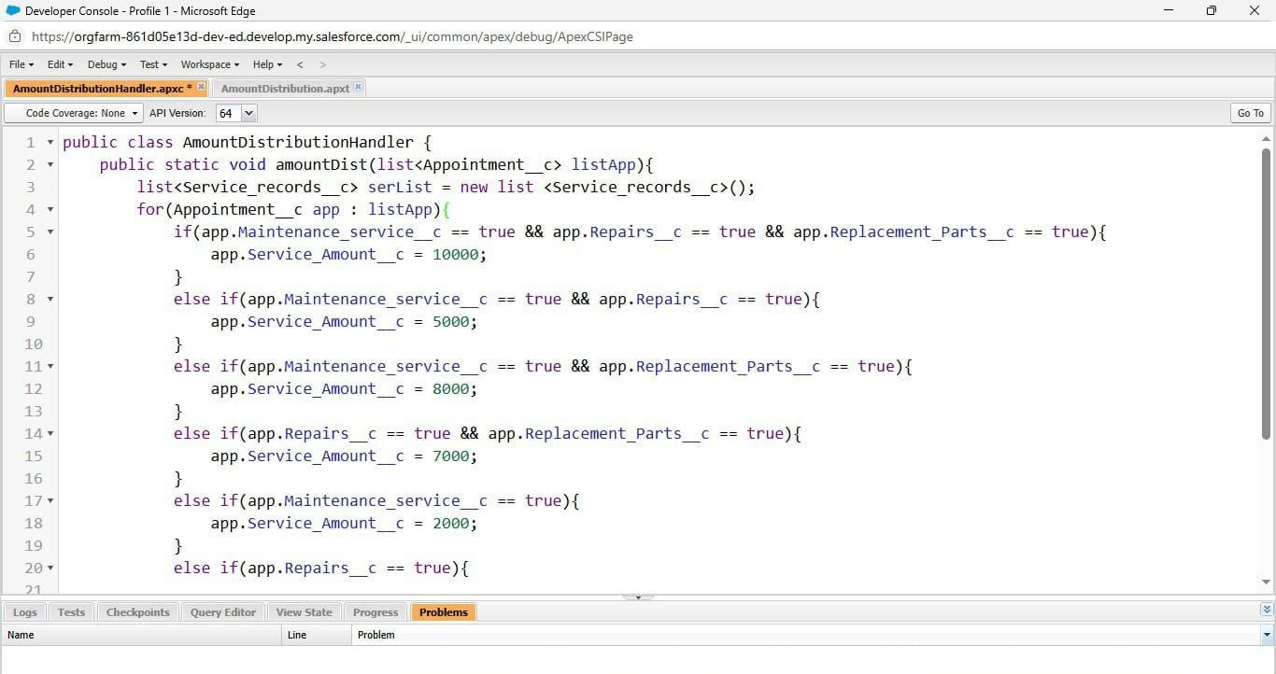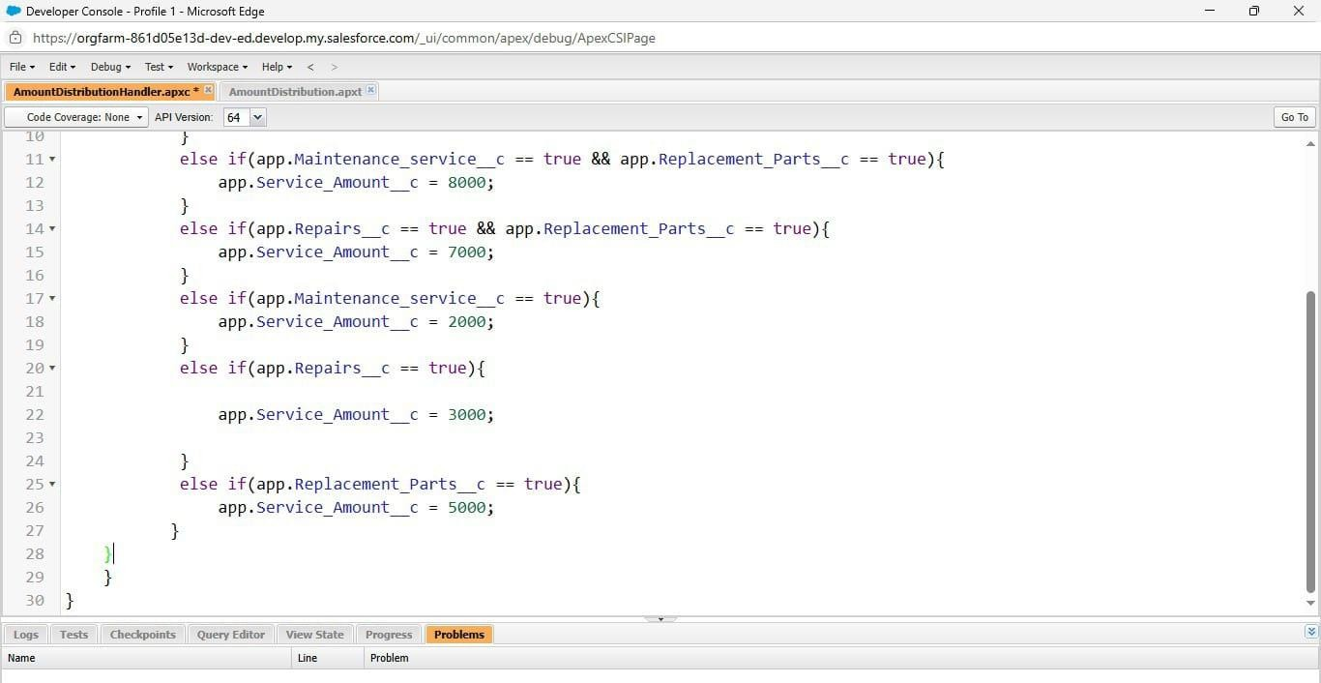

* **AmountDistribution.apxt (Trigger)**

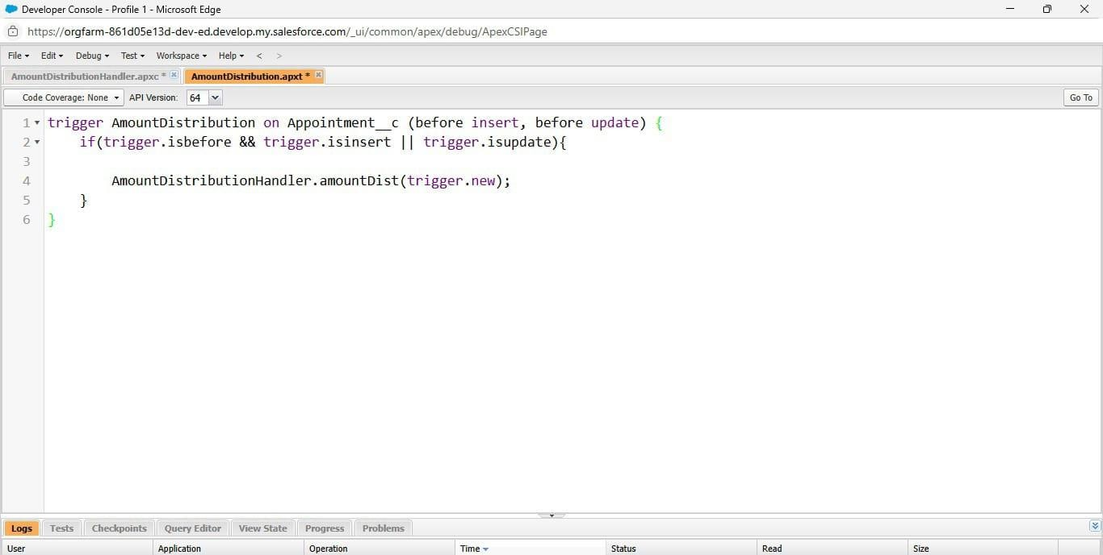

## Activity – 15

### Reports

#### Report Folder Creation

* Give the Folder label as “Garage Management Folder”, Folder unique name will

be auto populated.

* 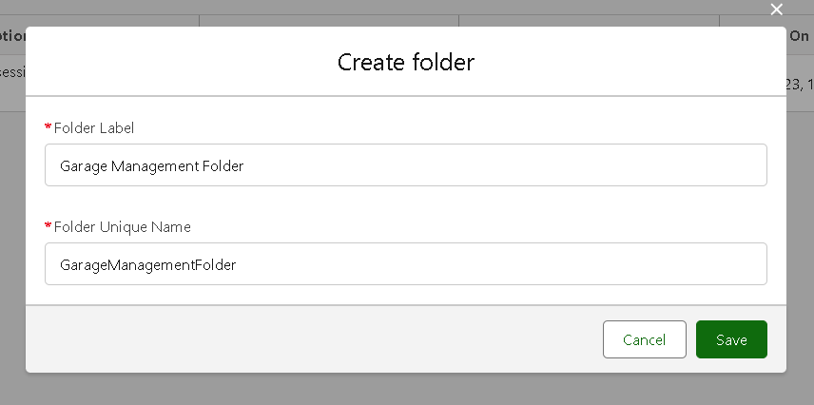

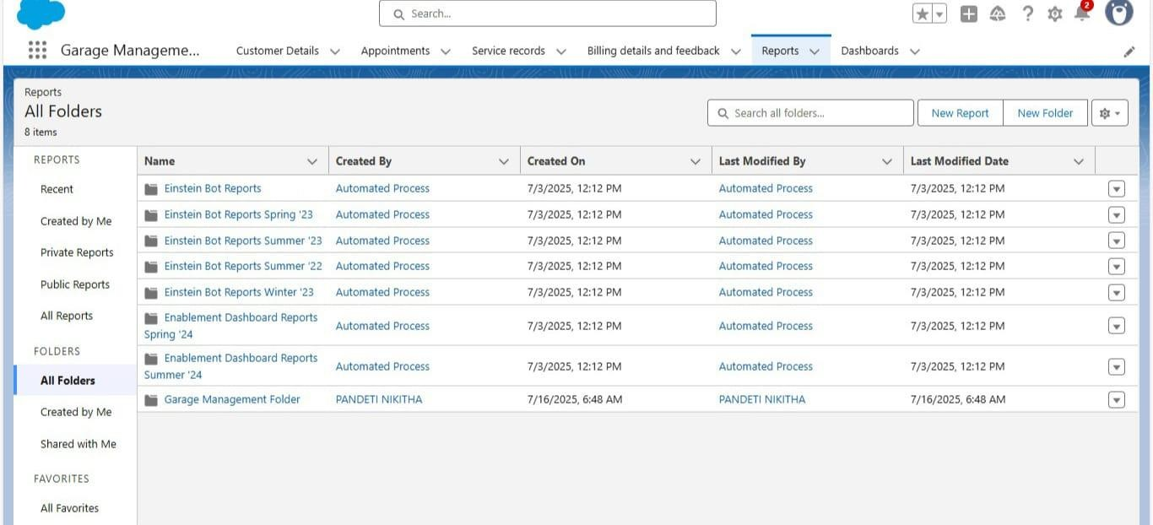

* 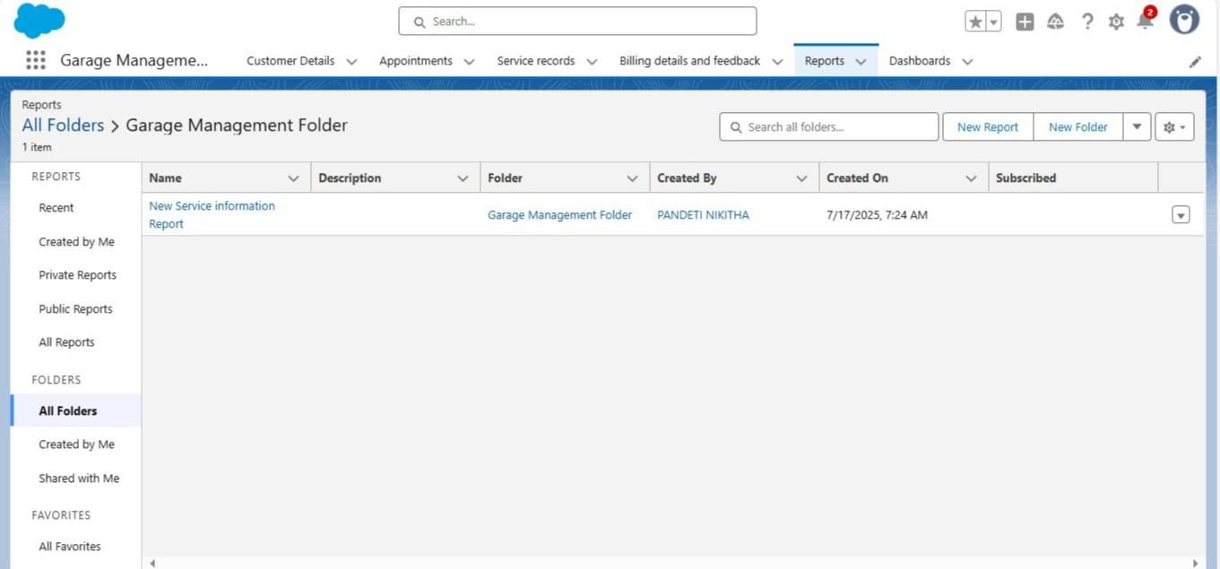

#### Sharing a folder:

* Select the share with as “roles”, in name field search for “manager”, give “view”

as access for that role.

* 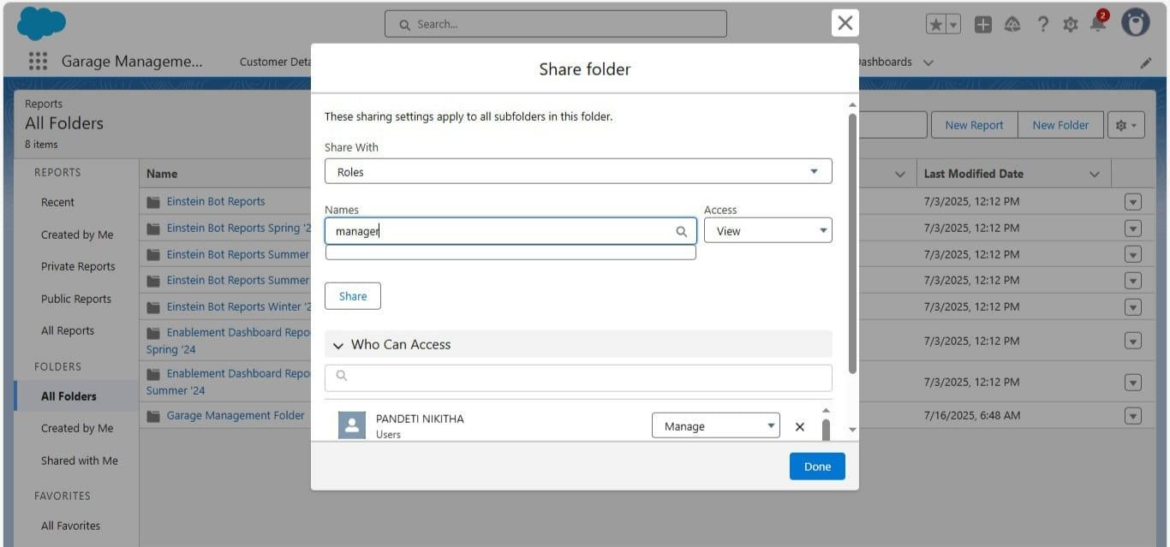
* Report Types:

1. Select the Primary object as “ Customer details” .
2. Give the Report type Label as “ Service information ”
3. Report type Name is autopopulated.
4. Keep the Description as same.
5. Select Store in Category as “ other Reports ”
6. Select the deployment status as “ Depolyed ”, click on Next.

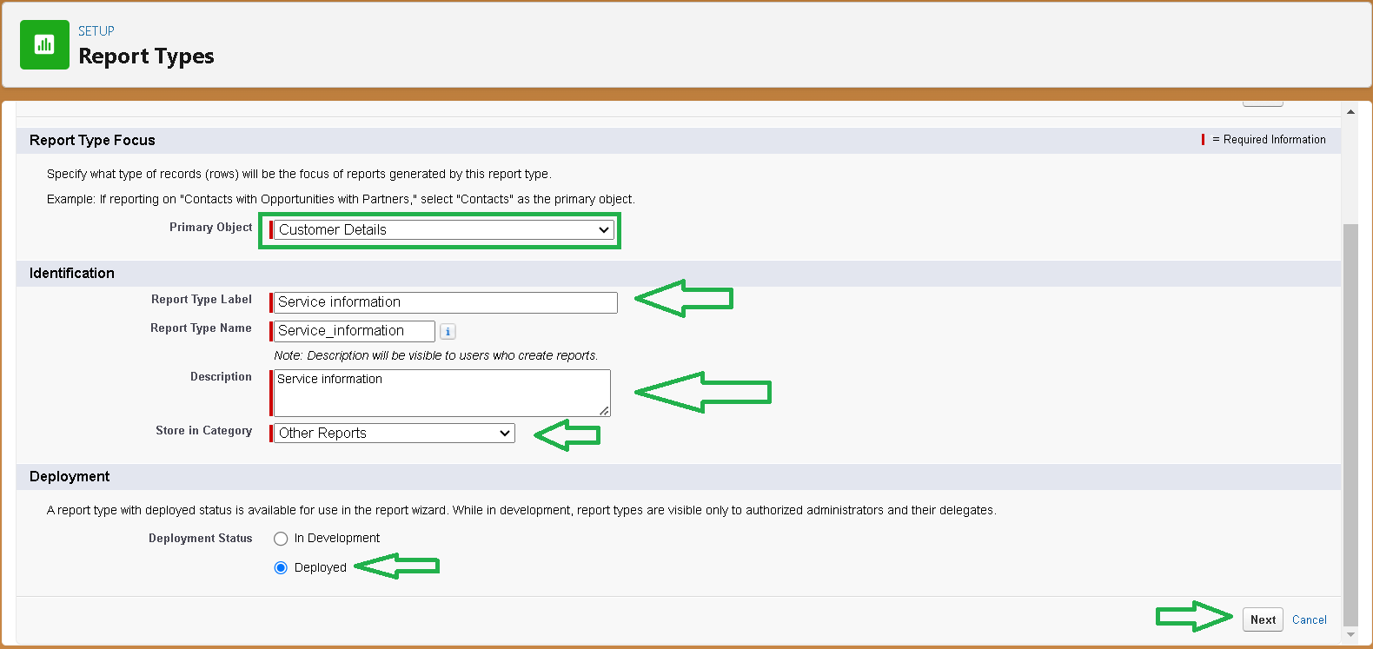

1. now , Click on Related object box.
2. Click on Select Object, choose Appointment Object as shown in fig.
3. 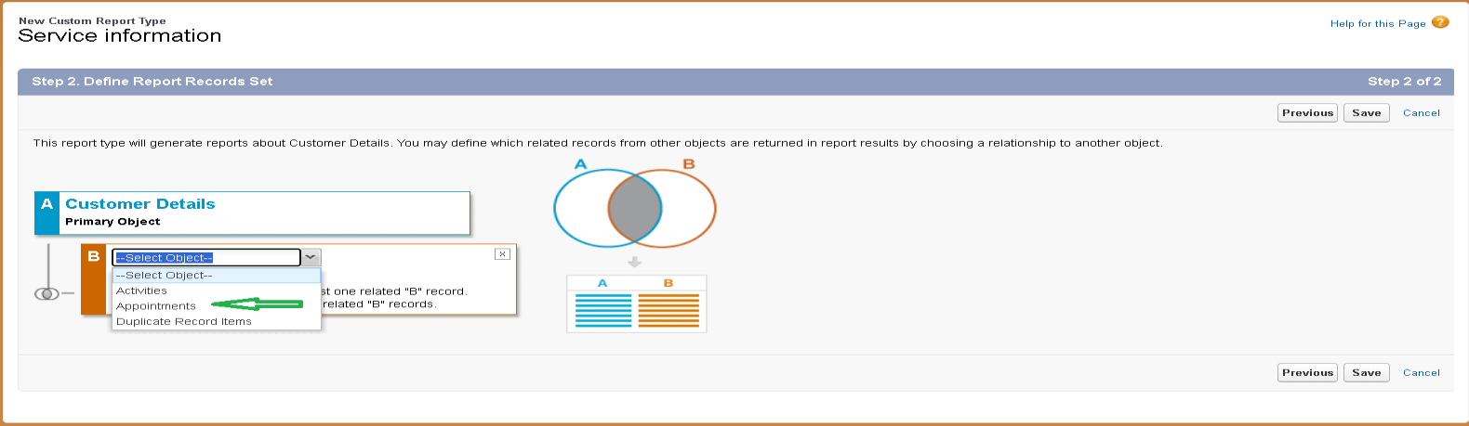

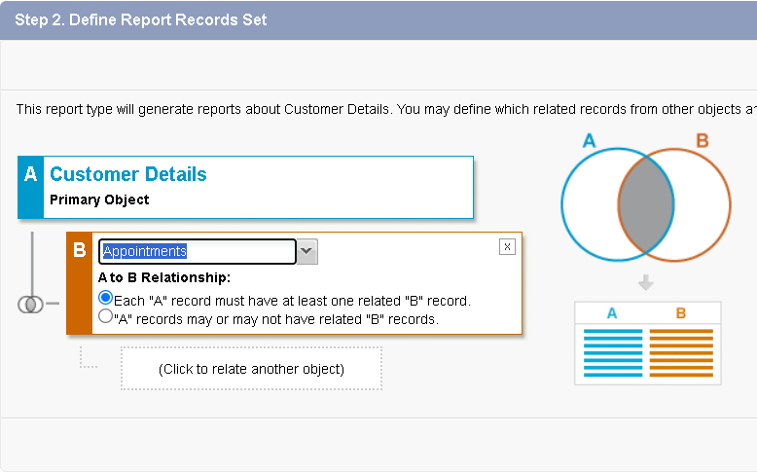

1. Again Click to relate another object.
2. And select the related object as “ service records”.
3. Repeat the process and select the related object as “ Billing details and feedback”.
4. 